DATA CLEANING & QUALITY ASSESSMENT
Global Life Expectancy Paradox Dataset
Comparison of the dataset before and after cleaning

1. Executive Summary
Purpose. This report documents the data-quality condition of the Global Life Expectancy Paradox dataset before cleaning and compares it with the supplied cleaned version. The review focuses on missing values, duplicate records, consistency of the dataset structure, and the effect of the cleaning process.
Overall finding. The dataset contains 204 records and 20 variables in both versions. The main improvement is the complete removal of missing cells: 154 missing values were present in the original dataset, compared with 0 in the cleaned file. The supplied cleaned file retains the same 204 rows, including 12 duplicate rows, so duplicate removal has not been carried out in the provided cleaned version.

2. Dataset Profile
Measure | Before cleaning | After cleaning
Rows | 204 | 204
Columns | 20 | 20
Missing cells | 154 | 0
Duplicate rows | 12 | 12
Numeric columns | 17 | 17
Column structure | 20 columns | 20 columns

3. Dataset Before Cleaning
The original workbook is structurally usable, but several fields contain missing observations. The missingness is concentrated in a small number of variables, with CO₂ emissions accounting for the largest share. The original file also contains exact duplicate rows.
Variable | Missing values | % of rows
co2_emissions | 59 | 28.9%
homicide_rate | 23 | 11.3%
secondary_school_enrollment_male | 14 | 6.9%
secondary_school_enrollment_female | 14 | 6.9%
unemployment | 10 | 4.9%
infant_mortality | 8 | 3.9%
life_expectancy_male | 6 | 2.9%
life_expectancy_female | 6 | 2.9%
fertility | 5 | 2.5%
forested_area | 4 | 2.0%
internet_users | 2 | 1.0%
gdp_growth | 1 | 0.5%
iso2 | 1 | 0.5%
gdp_per_capita | 1 | 0.5%
Missingness totals 154 cells across the dataset. The highest count occurs in co2_emissions (59 missing values), followed by homicide_rate (23). There are also 12 exact duplicate rows, meaning the raw file contains repeated country records.
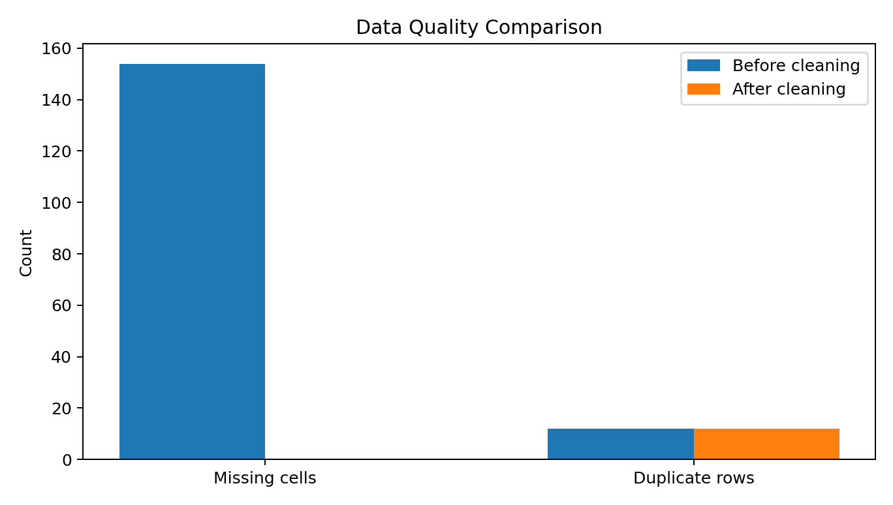
Figure 1. Comparison of key data-quality indicators before and after cleaning.

4. Cleaning Performed
The supplied cleaned dataset was examined against the original workbook to identify what changed. The cleaning process primarily addressed missing values while preserving the original dataset dimensions.
Variable | Values filled | Method identified
iso2 | 1 | Mode
life_expectancy_male | 6 | Median
life_expectancy_female | 6 | Median
gdp_per_capita | 1 | Median
gdp_growth | 1 | Median
unemployment | 10 | Median
infant_mortality | 8 | Median
fertility | 5 | Median
homicide_rate | 23 | Median
internet_users | 2 | Median
secondary_school_enrollment_female | 14 | Median
secondary_school_enrollment_male | 14 | Median
co2_emissions | 59 | Median
forested_area | 4 | Median
For the numeric variables, the replacement values in the cleaned file match the corresponding median of the non-missing observations in the original dataset. The missing ISO2 value was filled with the categorical mode. This approach keeps the number of records unchanged and avoids losing countries because of incomplete observations.

5. Dataset After Cleaning
The cleaned file contains no blank cells across the 20 variables. The column names, row count, and data types remain consistent with the original dataset. This makes the file more suitable for statistical analysis, visualization, correlation analysis, and subsequent modelling.
Quality indicator | Before | After | Change
Missing cells | 154 | 0 | 154 removed
Duplicate rows | 12 | 12 | No change
Rows | 204 | 204 | No change
Columns | 20 | 20 | No change

6. Effect on the Dataset
Median imputation removes gaps without deleting observations, but it can slightly alter summary statistics. The changes are most visible in variables with a larger amount of missing data. The table below provides selected descriptive statistics for comparison.
Variable | Mean before | Mean after | Median before | Median after
life_expectancy_male | 69.82 | 69.85 | 70.65 | 70.65
life_expectancy_female | 74.65 | 74.71 | 76.70 | 76.70
gdp_per_capita | 15,888.43 | 15,839.62 | 5,930.10 | 5,930.10
unemployment | 7.30 | 7.20 | 5.40 | 5.40
infant_mortality | 21.94 | 21.64 | 14.35 | 14.35
fertility | 2.74 | 2.73 | 2.30 | 2.30
homicide_rate | 6.83 | 6.34 | 2.50 | 2.50
internet_users | 54.72 | 54.76 | 58.95 | 58.95
co2_emissions | 224.64 | 168.72 | 31.30 | 31.30
forested_area | 31.50 | 31.51 | 31.55 | 31.55

7. Quality Assessment
Completeness: Improved substantially. All missing cells present in the original file have been populated in the supplied cleaned dataset.
Consistency: The same 20 variables are retained, and the data types remain appropriate for analysis.
Record retention: All 204 rows are retained, so the cleaning process did not discard observations because of missing values.
Duplicate control: Not fully addressed. The cleaned dataset still contains 12 exact duplicate rows.
Analytical readiness: The cleaned file is substantially more suitable for exploratory data analysis and modelling than the original because it contains no missing cells.

8. Recommendations
- Remove the 12 exact duplicate rows before any analysis where each country should appear only once.
- Verify whether duplicate country records are intentional or accidental before deletion.
- Document the median/mode imputation rule in the project methodology so the cleaning process is reproducible.
- For variables with relatively high missingness, especially co2_emissions, consider a sensitivity check to determine whether median imputation affects correlations or regression results.
- Retain the original workbook as the raw-data version and use the cleaned file as the analysis version.

9. Conclusion
The comparison shows a clear improvement in completeness between the two versions of the Global Life Expectancy Paradox dataset. The cleaned dataset preserves the original structure and all observations while eliminating the 154 missing cells through value imputation. However, duplicate records remain unchanged, so the dataset should undergo one final duplicate check before being treated as fully cleaned. With that additional step and appropriate documentation of the imputation method, the dataset will provide a stronger and more reliable foundation for further statistical and exploratory analysis.

